1. To understand architecture, we need to understand Application Layers.
2. The first layers is the **Presentation Layer (Presentation Tier).**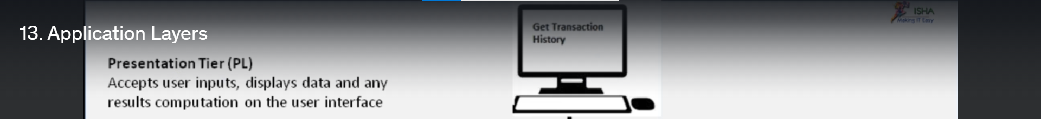This layer where a client makes a request like “Get Transaction History”.
3. 2nd Layer 🡺 Logic Layer (Business Logic Layer)  
   It has brain/logic where the command from a client is executed.  
   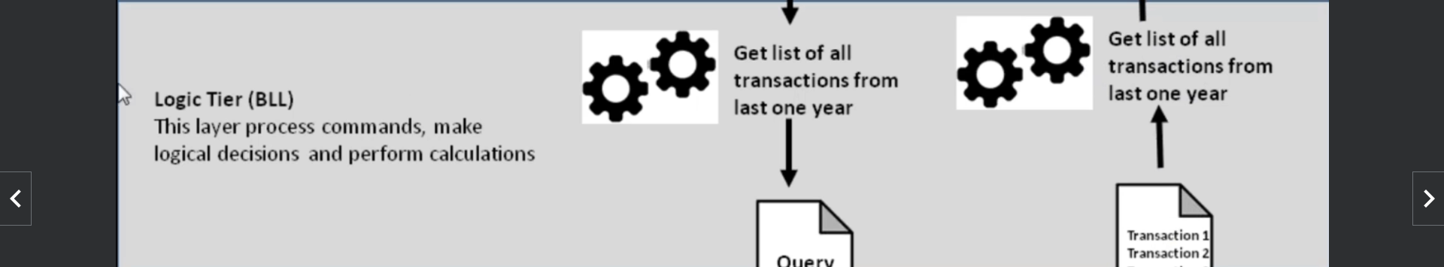
4. 3rd Layer 🡺 Data Lier
5. f